Assignment 2 answers

Group 13

1.

2.

3.

4.

(because of independence)

5. No, is independent of so the chance of H does not increase when we know that V is true.

6.

(given in exercise)

7.

(C is independent of V)

8.

9.

10.

11.

12.

( given in exercise 3, is given in exercise 1)

This is of the form which is what we were expecting

13.

14.

(Writing out the sum terms results in an expression of the form )

15.

(Writing out the sum terms results in an expression of the form )

16.

17.

18.

19.

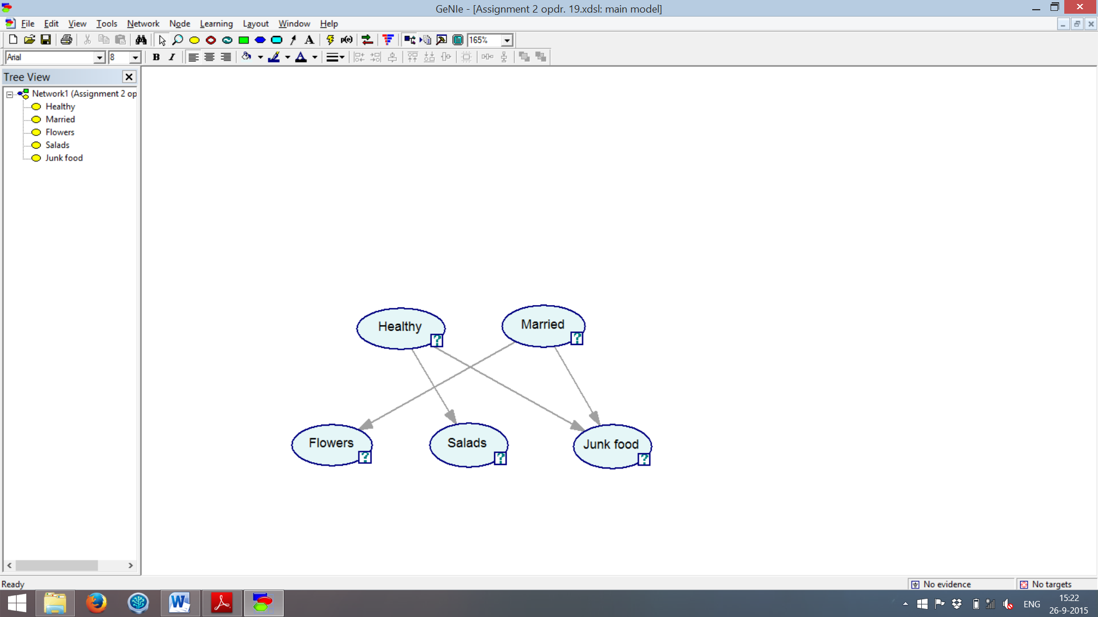

20.

21.  
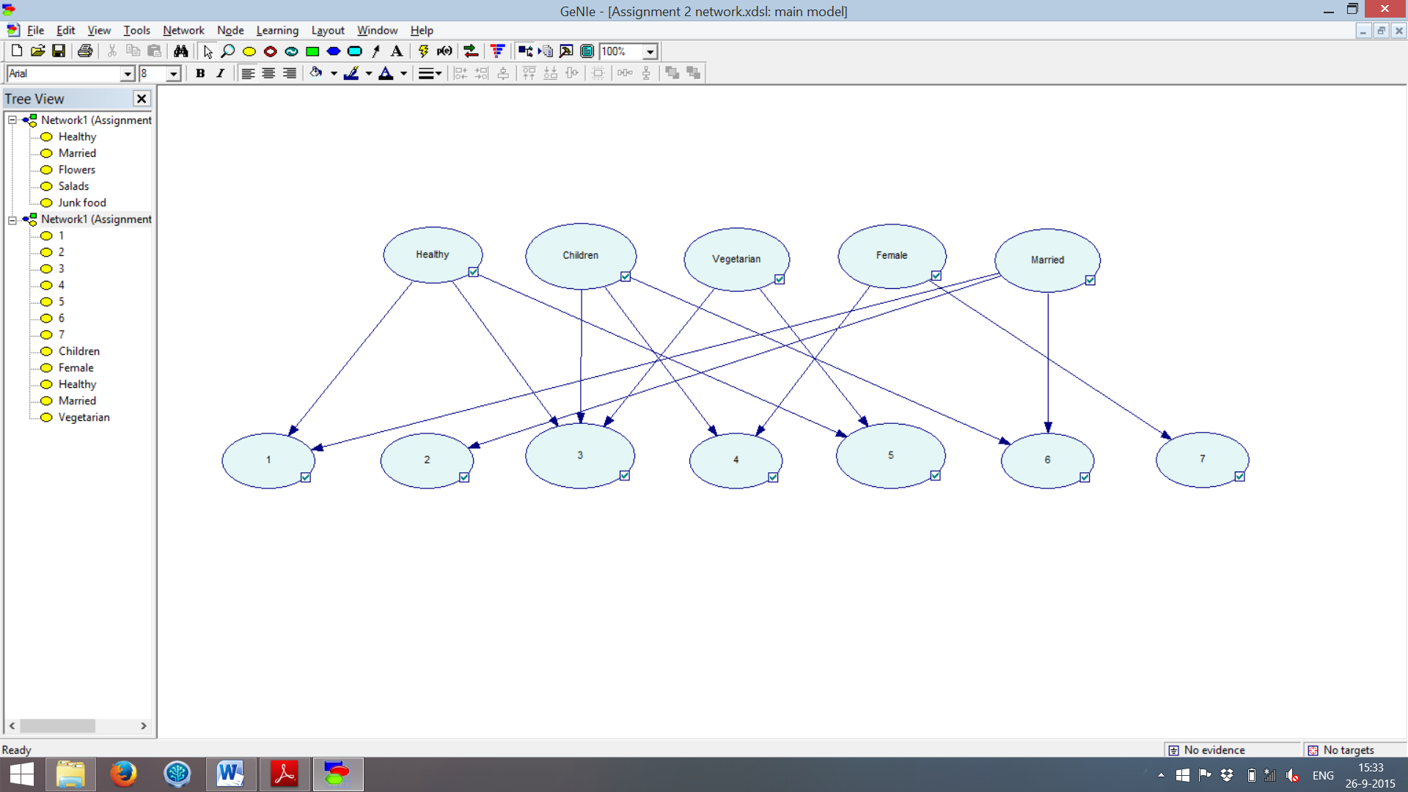  
22.  
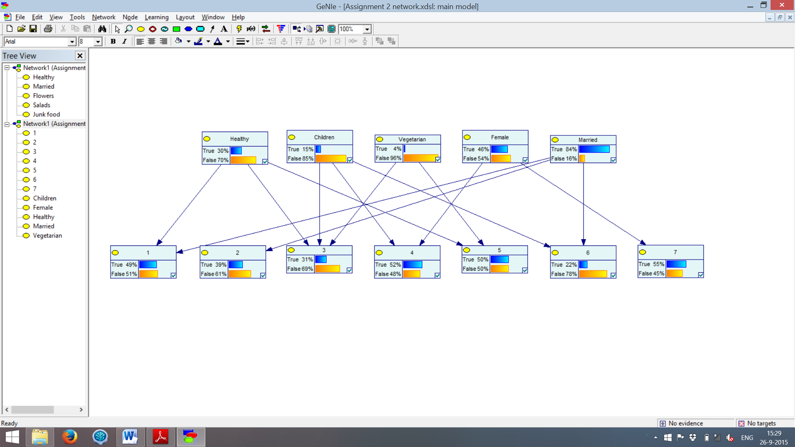

23.  
24.  
25.  
26.  
27.  
28.  
29.  
30.  
31.

This person is very likely to be married: . The person is also very unlikely to be healthy (), have children (), be a vegetarian (), or be female ().

32.  
33.

This person is very likely to be married: . The person is also very unlikely to be healthy (), have children () or be a vegetarian (). The chance of the person being female remains unchanged.